Chapter 6, Solution 17.

(a) 4F in series with 12F = 4 x 12/(16) = 3F
3F in parallel with 6F and 3F = 3+6+3 = 12F
4F in series with 12F = 3F
i.e. C_{eq} = 3F
- C_{eq} = 5 + [6x(4 + 2)/(6+4+2)] = 5 + (36/12) = 5 + 3 = 8F
- 3F in series with 6F = (3 x 6)/9 = 2F
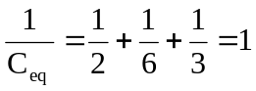
C_{eq} = 1F

